[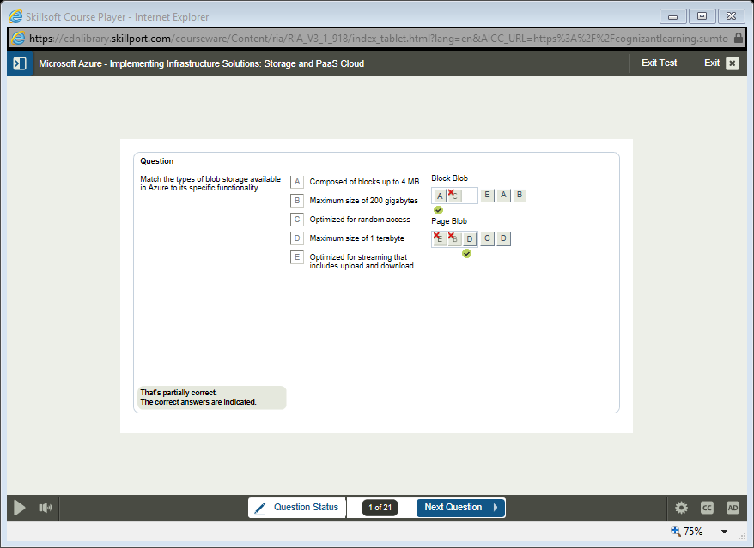](https://cdnlibrary.skillport.com/courseware/content/ria/ria_v3_1_918/index_tablet.html?lang=en&aicc_url=https%3a%2f%2fcognizantlearning.sumtotal.host%2flearning%2fapp%2fcontent%2fcontentadaptor.aspx&aicc_sid=127947257af6b8f75b583447a99f83db034bbd2f0d201842263911&cbtlaunch=cl_mazi_a04_it_enus_c&courseinfo=skins/olsa_ssl1db0&dynamic_skin_url=https://pvsp80apbabe.skillport.com:443/skillportbe/spctscontent/cmd.be&tryria=true&use508=0&signed_applet=true)

[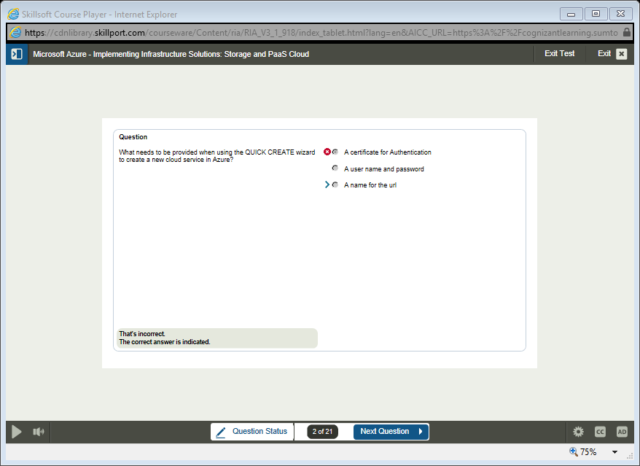](https://cdnlibrary.skillport.com/courseware/content/ria/ria_v3_1_918/index_tablet.html?lang=en&aicc_url=https%3a%2f%2fcognizantlearning.sumtotal.host%2flearning%2fapp%2fcontent%2fcontentadaptor.aspx&aicc_sid=127947257af6b8f75b583447a99f83db034bbd2f0d201842263911&cbtlaunch=cl_mazi_a04_it_enus_c&courseinfo=skins/olsa_ssl1db0&dynamic_skin_url=https://pvsp80apbabe.skillport.com:443/skillportbe/spctscontent/cmd.be&tryria=true&use508=0&signed_applet=true)

